LPMR 10, October 24-27, 2011
Meeting Overview
The 10th Layered Phenomena in the Mesopause Region workshop was held on October 24-27, 2011 on the campus of Virginia Tech University in Blacksburg, Virginia. The LPMR workshops have been held each two to three years over the last three decades, alternating between US and European locations. Their goal is to advance our understanding of ice layers in the region of the mesopause and the environment in which they form. Researchers from all perspectives participated, including those doing ground-based, rocket and satellite measurements, laboratory and modeling studies, and theoretical investigations of mesospheric ice phenomena and their coupled dynamical, radiative, chemical, and plasma environment. 40 participants enjoyed the comfortable, informal and collaborative environment that is a hallmark of the LPMR workshops. Support was kindly provided by the Scientific Committee on Solar-Terrestrial Physics (SCOSTEP), the International Commission on the Middle Atmosphere (ICMA), NASA, and Virginia Tech.
Mesospheric ice layers (or clouds) appear at high latitudes in the summertime, and have received increasing attention over the last several decades due to evidence that their numbers and brightness are increasing, and the ensuing debate over whether these increases are related to rising levels of greenhouse gases in the atmosphere or for other reasons. This growing interest has led to major advances in understanding which are reflected in the progress discussed at the 2011 LPMR workshop. New radar and lidar facilities in Antarctica promise to be a valuable resource for observational studies. New satellite data sets and innovative data analysis techniques were also discussed, such as tomographic imaging and coordinated observations with airplanes. Modeling studies have provided significant advances regarding the microphysical nature of the clouds, the role of dynamics - especially gravity waves, and insight about long-term trends in the clouds.
Models are now able to simulate the long-term increase observed by satellites in cloud occurrence frequency and brightness, and they suggest that while mesopause temperatures do not appear to have a significant trend in recent decades, the compression of the upper atmosphere due to overall cooling impacts water vapor so as to yield more and brighter clouds. However, other studies of observed short- and long-term variability in the clouds suggest that temperature controls many aspects of their seasonal behavior. An interesting connection is observed between ice in the summer mesosphere and temperatures in the winter stratosphere. Strong evidence also suggests that water vapor exhausted from the space shuttle engines during launch can, on some occasions, lead to increases in mesospheric ice. The impact of this result on long-term trends is not yet clear.
An important outcome of the workshop is the formation of six sub-working groups to attack focused areas where further work is needed. The topics are: unifying the many data sets; understanding observations of ice particle size distributions; the role of small scale forcing such as gravity waves and turbulence; the role of tides and local time variability; the role of metal layers and surface chemistry; and global connections.
A special issue of the Journal for Atmospheric and Solar Terrestrial Physics has been proposed to publish results from the workshop. The next LPMR workshop is planned for summer 2013 at the University of Leeds, England.

Organizing Committee:
Scott Bailey (VT), Matt DeLand (SAIC), Brentha Thurairajah (VT), Jim Russell (Hampton University), Wayne Scales (VT); Franz-Josef Lübken as co-chair of LPMR
Participants and Fees
There were a total of 40 participants including 8 students. The registration fee was $550 for each professional and $250 for each student. With increased attendance, this fee could have been reduced. These fees included all facility use, all meals for participants including snacks and two dinners at special locations, an extension to a local winery, and transportation to all events plus transportation to and from the airport for all those who requested it (about half the attendees). It also included meeting mugs and memory sticks as momentous of the workshop.
Funding Contributions
We gratefully acknowledge contributions from SCOSTEP ($3K), ICMA ($1K), and Virginia Tech. The funds from SCOSTEP and ICMA were used provide support to students and to pay the registration fee for the keynote speaker, John Olivero (his institution funded his travel). Two students were supported completely including travel and registration fee. One was from the University of Colorado and one was from Stockholm University. Virginia Tech paid for alcohol at the two dinners, registration fee for two professionals who would not have otherwise been able to participate, and paid travel and registration fee for an elder member of our community, Georg Witt, who has participated in all previous LPMR workshops.
Lessons Learned and Thoughts for the Future Workshop
The attendance for this meeting was about 30% less than previous meetings. Through polling those regular attendees who were not in attendance, it appears that the overwhelming cause of the reduced attendance was the autumn timing of the workshop which meant that it fell in the academic year. This was a change in date from the original plan made to accommodate key members of the community who were supporting a rocket campaign. It was strongly felt that the next workshop should occur in Summer 2013: July or June, not later than July. It is clear in the talks that the community could benefit from increased participating by those doing laboratory studies, in particular of ice index of refraction over a large wavelength range. Effort should be made to increase their involvement.
It was strongly felt that the momentum of the community continues to be strong and that biannual meetings should continue. It was also thought that increased collaboration within the group would be beneficial. The particle size working group that was active before LPMR 9 was a model for new subgroups that should be formed. These include (and the suggested leader): A reformed particle size working group (Bailey); Development of a unified data base including all available satellite data (Gary Thomas); Small scale structures (GW, turbulence) – (TBD); Tidally induced variations in NLCs – Mike Stevens; Metal layers, chemistry – suggest as focus of next meeting, (will ask John Plane if he wants to lead an initiative in that area); and Global connections – (Heiner)

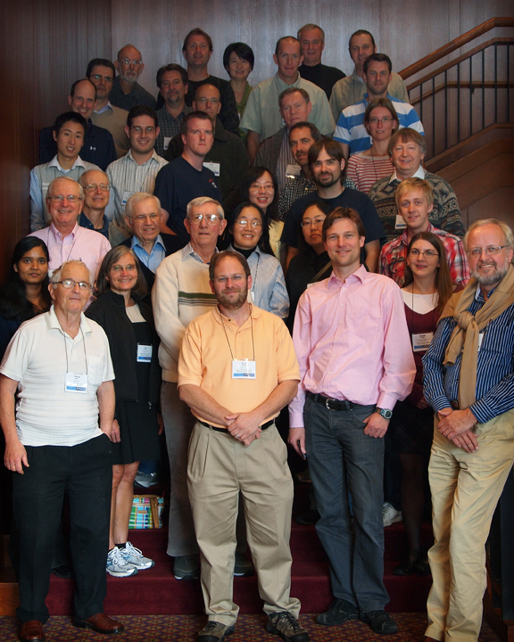
The participants of the 10th LPMR Workshop at Virginia Tech. Not shown are invited keynote speaker John J. Olivero, James M. Russell III, Chad Fish, Justin Yonker, and David Fritz.

